Tugas praktikum kelompok

Kelompok 3

Nama anggota :

* Farhan dwi atmaja (2022240009)
* kevin alexander (2022240004)
* Joseph Budiman Maruliasi (2022240014)
* Farida fuad bajamal (2022240007)

**Bab 1 pointer**

b.operator reference (*)

contoh program 2

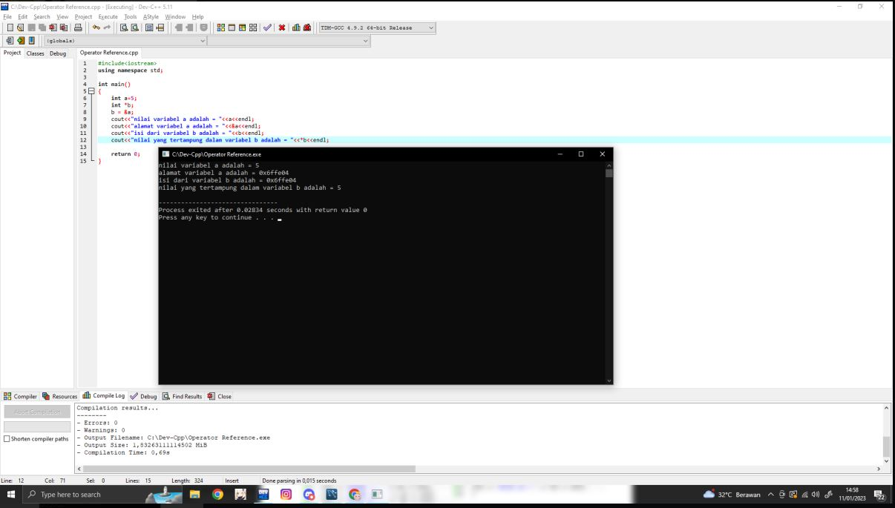

**Bab 2 array**

**2.1 array satu dimensi**

**Program 12**

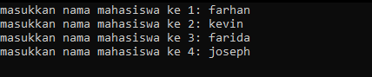

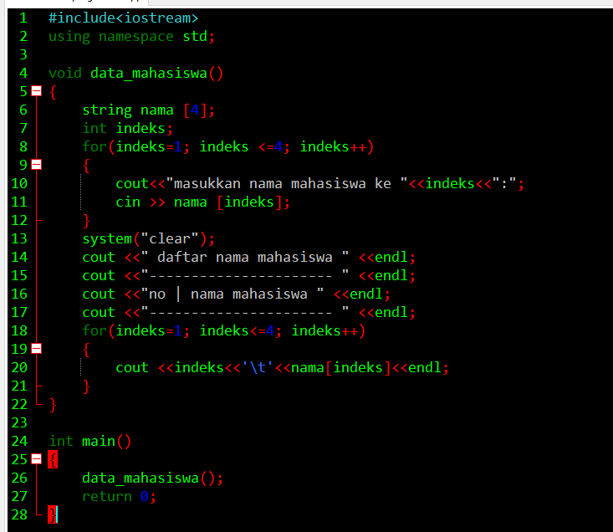

Bab 5 stack

Program 19

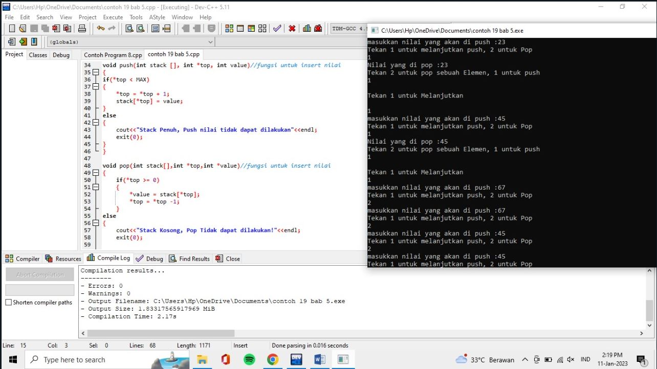

Bab 6 queue

Program 24

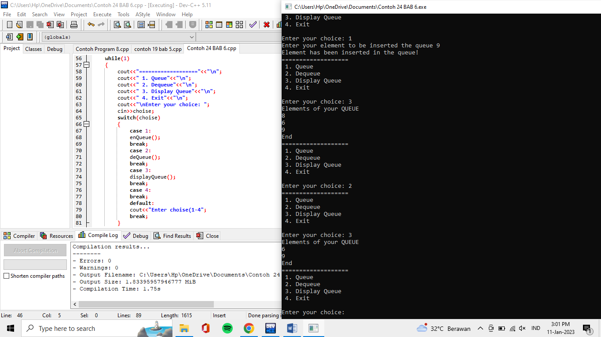

Bab 7 tree

Program 26

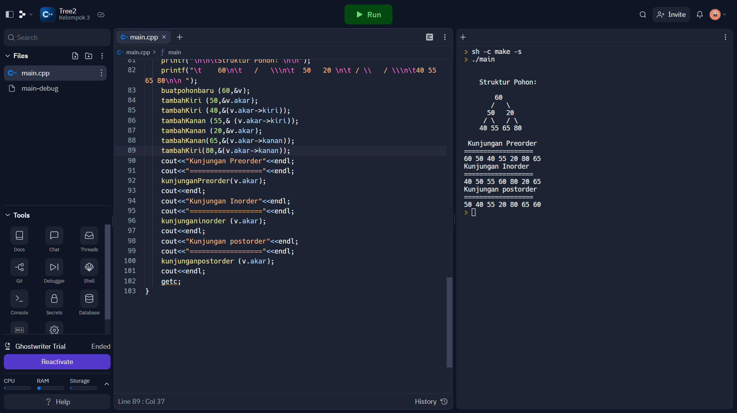

Bab 8 graph : program 27

